Frankenstein hyperbook

by Emily rose Skirtich

- Lesson overview

  - Basic information
    - Students will engage in the planning of a mock trial of Frankenstein v. the creature by coordinating witnesses, plaintiff attorneys, and defense attorneys, in order to present evidence against each party

    - Students will use closereading of the text of mary shelley’s Frankenstein to present written character statements, opening statements, closing statements, and testimonies to the jury

    - Students will rely upon research of the text, videos of other students participating in mock trials online, websites that assist in the process and procedures of a mock trial, worksheets with glossary of terms provided by the teacher, and worksheets of proper mock trial procedures provided by the teacher

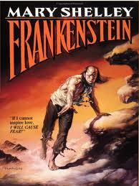
  - Introduction to the topic
    - The honors IV seniors have recently just completed reading mary shelley’s Frankenstein and engaged in various class discussions about the text

    - The students will use their prior knowledge about the text to incorporate their textual evidence of the mock trial as well as their information gathered from classroom discussions to present their case

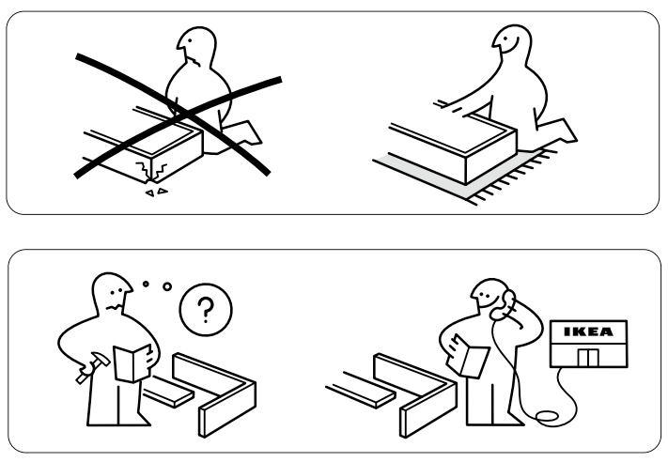
  - Instructions

    - First, students will receive their roles of the mock trial as chosen by the teacher

    - Then, students will then go through their textbooks and gather textual evidence to support their roles. Students will gather this information located in the specific area of the hyperbook provided for students’ notes

    - students will then utilize the external links to the websites provided to prepare their character statements, opening statements, closing statements, and testimonies, incorporating their notes and textual evidence to state their claims

    - next, students will reference the worksheets as internal links in the hyperbook to prepare for the procedures of the mock trial

    - students will then gather all of the information throughout their preparation, compose, and submit their witness and character statements into the hyperbook in the areas provided.

After the students compose and submit their statements to the teacher via the hyperbook, the student will then use 5 of the vocabulary terms from the glossary of terms in the sentences provided in order to check their understanding of the lesson’s vocabulary. The students will check their understanding by referencing the websites from the Adapted sources.

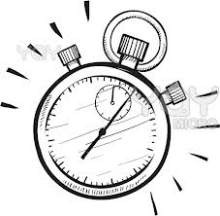
  - Allotted time

    - Students will have 3 days from time the assignment is e-mailed out to the entire class to complete the assigned work.

    - Students will send their completed hyperbook to the teacher’s e-mail account or turn in a hardcopy when they arrive to class on the assigned due date.

  - Lesson goals

students already know… | 1.  the goings-on in the text of Frankenstein and each character’s role within the novel | 2.  how to navigate a website for important and irrelevant facts | 3.  how to gather information and create their own opinions in conjunction with textual information and class discussions
students will be able to… | 1.  accurately use the vocabulary from the glossary of terms in sentences provided by the teacher. | 2.  gather textual evidence and conduct their own research per their respective roles assigned in the mock trial. | 3.  compose their own character statements and witness statements by including their found research data, textual information, and class discussions

Name:
Date:
Miss skirtich’s class English literature

objective: students will accurately use the vocabulary from the glossary of terms in sentences provided by the teacher.
How much time do we have???
You have 3 days to complete this assignment from the date that it is assigned.

- First, Peruse these websites to gain a bit of information about the glossary of terms that we will be using throughout the mock trial and during mock trial procedures. Get a grasp of the definitions and their meanings, as we will encounter almost all of the terms throughout the mock trial.
- http://definitions.uslegal.com
- www.uslegal.com
- www.americanbar.org
- www.courts.state.pa.us

- next, use your best judgment and insert the appropriate term into the sentences provided below. Remember, this is to help jog your memory and gain a better understanding of the terms while we participate in the mock trial.

- When Susie got home late after a night out with her friends, her parents used their method of ____________________ to find out where she went and with whom.

- After the man got into a car accident at the intersection, a ___________________ stopped her own car and told the police officer what she saw happen during the accident.

- When the community counsel did not know what to do in the sticky situation with the leftover money from the fundraiser, they called upon the _____________________ to advise them with what their plan of action should be.

- at the school board meeting, the board members squabbled and __________________ over which elementary school should be voted to expand its structure.

- after completing those sentences, you now have a better understanding of the goings-on of the mock trial terminology. With this in mind, go back through your novel and gather the relevant information about your role. Use the notes section and the website here to access the e-book of Frankenstein.

Frankenstein online text

http://www.gutenberg.org/files/84/84-h/84-h.htm

Notes from class discussions: ________________________________________________________________________________________________________________________________________________________________________________________________________________________________________________________________________________________________________________________________________________________________________________________________________________________________________________________________________________________________________________________________________________________________________________________________________________________________________________________________________________________________________________________________________________________________________________________________________________________________________________________________________________________________________________________

Notes from text of Frankenstein: ________________________________________________________________________________________________________________________________________________________________________________________________________________________________________________________________________________________________________________________________________________________________________________________________________________________________________________________________________________________________________________________________________________________________________________________________________________________________________________________________________________________________________________________________________________________________________________________________________________________________________________________________________________________________________________________

Notes from internet resources: ________________________________________________________________________________________________________________________________________________________________________________________________________________________________________________________________________________________________________________________________________________________________________________________________________________________________________________________________________________________________________________________________________________________________________________________________________________________________________________________________________________________________________________________________________________________________________________________________________________________________________________________________________________________________________________________

- now, reflecting back on class discussions and your own notes from the text about your character, prepare a character statement that could be used in the mock trial to support either the creature or Dr. Frankenstein in his actions. Use the internet resources to assist you in composing an accurate character statement and including the textual information appropriately for your respective roles. Use the space provided to record your character statement.

my character statement
___________________________________________________________________________________________________________________________________________________________________________________________________________________________________________________________________________________________________________________________________________________________________________________________________________________________________________________________________________________________________________________________________________________________________________________________________________________________________________________________________________________________________________________________________________________________________________________________________________________________________________________________________________________________________________________________________________________________________________________________________________________________________________________________________________________________________________________________________________________________________________________________________________________________________________________________________________________________________________________________________________________________________________________________________________________________________________________________________________________________________________________________________________________________________________________________________________________________________________________________________________________________________________________________________________________________________________________________________________________________________________________________________________________________________________________________________________________________________________________________________________________________________________________________________________________________________________________________________________________________________________________________________________________________________________________________________________________________________________________________________________________________________________________________________________________________________________________________________________
Enrichment activities
Let’s take this project one step further! After preparing your character statements, work to compose the opening statement for either Frankenstein or the creature. What kinds of resources would you use from the websites provided. Use the space below to compose your statement.

My opening statement for Frankenstein or the creature
(circle one)
___________________________________________________________________________________________________________________________________________________________________________________________________________________________________________________________________________________________________________________________________________________________________________________________________________________________________________________________________________________________________________________________________________________________________________________________________________________________________________________________________________________________________________________________________________________________________________________________________________________________________________________________________________________________________________________________________________________________________________________________________________________________________________________________________________________________________________________________________________________________________________________________________________________________________________________________________________________________________________________________________________________________________________________________________________________________________________________________________________________________________________________________________________________________________________________________________________________________________________________________________________________________________________________________________________________________________________________________________________________________________________________________________________________________________________________________________________________________________________________________________________________________________________________________________________________________________________________________________________________________________________________________________________________________________________________________________________________________________________________________________________________________________________________________________________________________________________________________________________

remedial activities
after preparing your textual and internet research, reading through and studying the worksheets with the glossary of terms and mock trial procedures, view this youtube video of a.p. students conducting their own mock trial. Based upon your knowledge of mock trials and your prior knowledge, what do you think these students did a good job on when they prepared their mock trial? What could they have improved? Did they use the terms appropriately? Did they incorporate the appropriate textual references in their mock trial? Comment on these and relevant questions in the space below, along with your suggestions on other improvements.

http://www.youtube.com/watch?v=QO2gCVMoha8
_______________________________________________________________________________________________________________________________________________________________________________________________________________________________________________________________________________________________________________________________________________________________________________________________________________________________________________________________________________________________________________________________________________________________________________________________________________________________________________________________________________________________________________________________________________________________________________________________________________________________________________________________________________________________________________________________________________________________________________________________________________________________________________________________________________________________________________________________________________________________________________________________________________________________________________________________________________________________________________________________________________________________________________________________________________________________________________________________________________________________________________________________________________________________________________________________________________________________________________________________________________________________________________

Student feedback and evaluations
After completing this hyperbook activity, please rate the following questions from 1 through 5, 1 being the least satisfied and 5 being the most satisfied.

I gained valuable information 1 2 3 4 5
This activity was fun and educational 1 2 3 4 5
I learned a lot in this lesson 1 2 3 4 5
I understood in my native language 1 2 3 4 5
I had the resources I needed 1 2 3 4 5
To succeed
The internet resources were 1 2 3 4 5
Helpful in my research

Any other comments? Suggestions? Feedback?

_____________________________________________________________
_____________________________________________________________
__________________________________________________________

Frankenstein mock trial:
glossary of terms
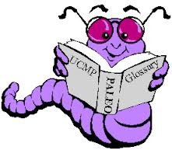
Source: http://definitions.uslegal.com
Term: | Simple meaning:
Defendant | The person accused of the crime
Plaintiff | The person who initiates court action by filing a complaint
Witness | A person who testifies under oath in a trial
Medical expert | A qualified physician to testify on a particular medical field
Psychologist/Ethicist | A person who studies the mind and behavior/a person whose ethical judgment is trusted by the community
Attorneys for the Plaintiff | Employed by the plaintiff to manage the case; upholds the court of law with integrity; to be true to the court and to his/her client
Attorneys for the Defendant | Employed by the defendant to manage the case; upholds the court of law with integrity; to be true to the court and to his/her client
Court Reporters | Record written accounts of verbatim speech within the court for legal proof
Juror | A person serving on the jury who takes an oath to act fairly and judge without preconceptions
Judge | A government official with authority to decide lawsuits brought before courts
Bailiff | A law enforcement officer who keeps order within the classroom
Opening Statement | The introduction to the case by the attorneys for both sides at the beginning of the trial, only containing factual evidence and not argumentative
Interrogation | The process of questioning by police
Cross-examination | The questioning of a witness by a member of the opposite party
Closing Argument | The final argument made by each party’s attorneys, allowing a last chance to lawyers to be persuasive before the judge or jury begin deliberations
Deliberation | The act of examining, considering, analyzing, and discussing the reasons for and against a measure

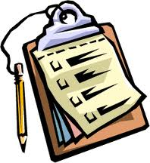
Frankenstein
MOCK TRIAL PROCEDURES

Before participating in a mock trial, it is important to be familiar with the events that take place during the trial and the order in which they occur.
Observe the following rules in the courtroom AT ALL TIMES:
- Rise when addressing the judge
- Direct all remarks to the judge or witness, NEVER to opposing counsel
- Ask permission from the judge before approaching the witness or witness or Judge’s bench
Court Procedure:
- Opening of the Court:

  - The bailiff calls the court to order

  - Everyone remains standing until the judge enters AND is seated. The bailiff then asks everyone to be seated.

- The judge may ask members of the court to identify themselves.

- Swearing in the Witness
The clerk will stand and raise his/her right hand, asking each witness to testify under oath.

- Opening Statements

  - Plaintiff begins with the opening statements. Attorneys should introduce the case in the future tense (i.e. the evidence WILL show, the witness WILL testify, etc.)

  - The defense attorneys follow with their opening statements.

- Direct Examination
The plaintiff’s attorney conducts the interrogation of all its own witnesses. At this time, testimony and other evidence is presented.
- Cross-Examination

- After the attorney for the plaintiff has completed interrogating of the witness, the defendant’s attorney cross-examines the witness.

- After the plaintiff calls its final witness, the plaintiff should inform the court that the plaintiff has no further witness and rests it case.
- The defense will begin its case by calling its first witness.

- Closing Arguments

- Attorney for the plaintiff reviews and analyzes the evidence as presented, indicates how the evidence has satisfied the elements of the charge or claim.

- The closing argument for the defense is essentially the same as for the plaintiff. It should indicate how the evidence does not satisfy the elements of the charge or claim.

- Jury Deliberations
The Jury will then deliberate either privately or aloud in front of the rest of the Court to reach its verdict. Once a decision is reached, one member of the Jury will read the verdict aloud to the Court.
Adapted Sources: www.uslegal.com
www.americanbar.org
www.courts.state.pa.us

1. HyperBook was created using advanced _______/40
word-processing skills that include: WordArt,
Text Color, Tables and Columns, and Working Hyperlinks.

2. Lesson Objectives are clear specific to help _______/40
students acquire basic knowledge of the given content material.

3. The student activity shows evidence that _______/40
it addresses each lesson goal.

4. The directions are clear/ precise and appropriate for the _______/40
student ability level. They should be easy understand and follow.

5. The HyperBook shows a good combination in _______/40
the use of images/embedded images, charts and graphics,
tables, and website links.

6. Overall the HyperBook shows a good combination ______/75
of all 5 steps in the creation process and the materials are linked
and accessible.

7. Include a statement describing enrichment and reinforcement ______/25
activities to adapt to gifted students and students with disabilities.
Posted the assignment to the Google Sites page.

